Nama : Nanang Setyawan

NIM : 185410025

Kelas : TI 1

LISTING

ALGORITMA DAN PEMROGRAMAN

PERTEMUAN KE-4

**PRAKTIK 1**

1. Open documentation in string class

<http://docs.oracle.com/javase/8/docs/api>

1. Explain string class documentation

**PRAKTIK 2**

1. Using method length

public class LatihanString1{

public static void main(String[]args){

String name = "Nanang.S";

System.out.println(name.length());

}

}

Output:

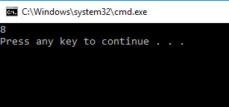

1. Access each character in string

public class LatihanString2{

public static void main(String[]args){

String str= "Hello, Nanang";

System.out.println(str.charAt(0));

System.out.println(str.charAt(1));

System.out.println(str.charAt(2));

System.out.println(str.charAt(3));

System.out.println(str.charAt(4));

System.out.println(str.charAt(5));

System.out.println(str.charAt(6));

System.out.println(str.charAt(7));

System.out.println(str.charAt(8));

System.out.println(str.charAt(9));

System.out.println(str.charAt(10));

System.out.println(str.charAt(11));

System.out.println(str.charAt(12));

}

}

Output :

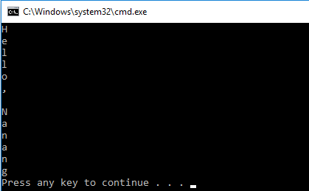

1. Take index value from character in string

public class LatihanString3{

public static void main(String[]args){

String phoneNum= "0823-9473-669";

int idx1= phoneNum.indexOf('-');

System.out.println("index of first dash: "+idx1);

int idx2= phoneNum.indexOf('-',4);

System.out.println("second dash index: "+idx2);

}

}

Output :

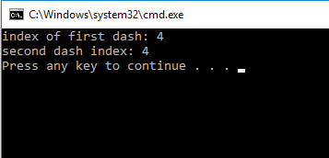

1. Take substring from string

public class LatihanString4{

public static void main(String[]args){

String greeting= "Hello, world";

String sub= greeting.substring(0,5);

System.out.println(sub);

String w= greeting.substring(7,11);

System.out.println(w);

String tail= greeting.substring(7);

System.out.println(tail);

}

}

Output :

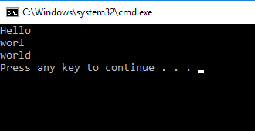

1. Change character in string

public class LatihanString5{

public static void main(String[]args){

String str="Using String replace to replace character";

String newStr= str.replace("r","R");

System.out.println(newStr);

}

}

Output :

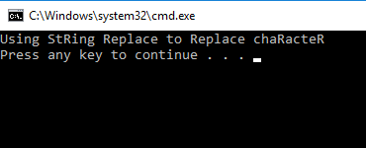

1. Change character to string

public class LatihanString55{

public static void main(String[]args){

String str="Using String replace to replace character";

String newStr= str.replace("r","R");

System.out.println(newStr);

String newFirstStr= str.replaceFirst("re","RE");

System.out.println(newFirstStr);

}

}

Output :

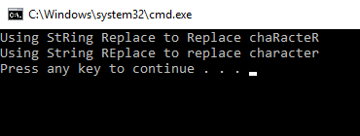

1. Declarate and make string

public class LatihanString6{

public static void main(String[]args){

String s1= "Susan";

String s2= "Robert";

s1= s1+s2;

System.out.println(s1);

}

}

Output :

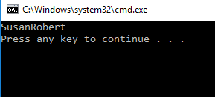

1. Combine string

public class LatihanString7{

public static void main(String[]args){

String newString= "Learning Java"+8;

System.out.println(newString);

String newString1="8"+8;

System.out.println(newString1);

}

}

Output :

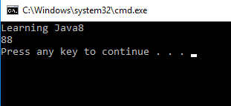

1. Use concat method

public class LatihanString8{

public static void main(String[]args){

String myString= "Hello";

myString= myString.concat("World");

System.out.println(myString);

}

}

Output :

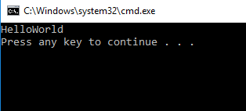

1. Compare method

public class LatihanString9{

public static void main(String[]args){

String s1= "Susan";

String s2= "Susan";

String s3= "Robert";

//Return 0 because s1 is identical to s2

System.out.println(s1.compareTo(s2));

//Return >0 because 'S' follow 'R';

System.out.println(s1.compareTo(s3));

//Return <0 becouse 'R' precedes 'S'

System.out.println(s3.compareTo(s1));

}

}

Output :

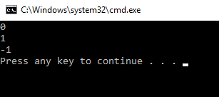

**PRAKTIK 3**

1. Use random number by integer type

import java.util.Random;

public class LatihanRandom1{

public static void main(String[]args){

Random rndNum= new Random();

int randomNum= rndNum.nextInt();

System.out.println("Random Number: "+ randomNum);

}

}

Output :

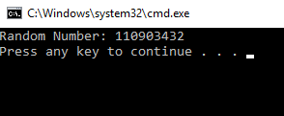

1. Make a random number

import java.util.Random;

public class LatihanRandom2{

public static void main(String[]args){

Random num= new Random();

System.out.println("Random Number 1:"+ num.nextInt());

System.out.println("Random Number 2:"+ num.nextInt());

System.out.println("Random Number 3:"+ num.nextInt());

System.out.println("Random Number 4:"+ num.nextInt());

System.out.println("Random Number 5:"+ num.nextInt());

}

}

Output :

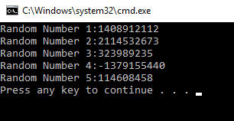

1. Use double random number

import java.util.Random;

public class LatihanRandom3{

public static void main(String[]args){

Random num= new Random();

double randomNum= num.nextDouble();

System.out.println("Random Number:"+ randomNum);

}

}

Output :

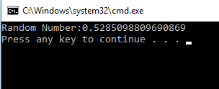

1. Make random character with range

import java.util.Random;

import java.util.Scanner;

public class Lottery{

public static void main(String[]args){

Scanner numberScanner= new Scanner(System.in);

System.out.println("Enter a number between 1 and 10:");

int userNum= numberScanner.nextInt();

Random rnd= new Random();

int winningNum= rnd.nextInt(10)+1;

System.out.println("Your number:"+ userNum);

System.out.println("The winning number is:"+ winningNum);

}

}

Output :

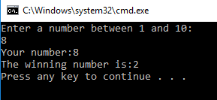

**PRAKTIK 4**

1. Use sqrt method

public class LatihanMath{

public static void main(String[]args){

System.out.println(Math.sqrt(121.0));

}

}

Output :

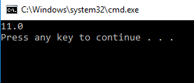

1. Use min and abs method

public class LatihanMath2{

public static void main(String[]args){

double result= Math.min(3,7)+ Math.abs(-50);

System.out.println("Result is " + result);

}

}

Output :

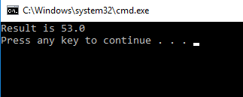

1. Use PI field

import java.util.Scanner;

public class AreaOfCircle{

public static void main(String[]args){

Scanner sc= new Scanner(System.in);

System.out.println("Enter the radius:");

double radius= sc.nextDouble();

double area= Math.PI*radius*radius;

System.out.println("The area of circle is: "+ area);

}

}

Output :

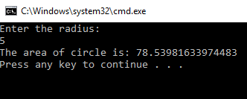

**LATIHAN**

1. Count BMI (Body Mass Index) with formula

import java.util.Scanner;

public class Latihan{

public static void main(String[]args){

double weight, height;

double BMI;

Scanner input= new Scanner (System.in);

System.out.print("Enter your weight in pounds:");

weight=(int)input.nextDouble();

System.out.print("Enter your height in inches:");

height=(int)input.nextDouble();

height= Math.pow(height,2);

BMI= ((weight*70)/height);

System.out.println("Your body mass index is "+ BMI);

}

}

Output:

